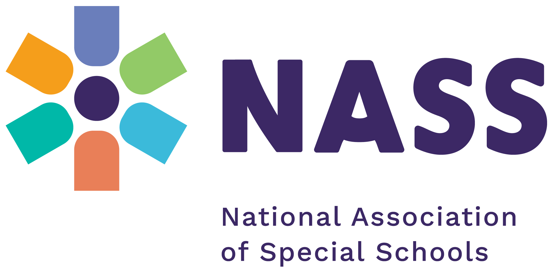

NASS Leadership Development Programme 2027
Application form

Before applying, please make sure you have carefully read the programme flyer, which contains important information about the programme content, dates and location. Please also read the terms and conditions on page 3 of this application form carefully.
Deadline for applications is 4 pm, Friday 16th October

Applicant details
Name
Job title
Name of school/organisation
Full address
(please include postcode)
Email*
Mobile phone

*Applicants will be notified by email if they are successful, so please make sure to include an email address.

Health, accessibility and special requirements
Please let us know if you have any medical condition, disability (physical or learning) or other support needs that we should be aware of in order to make appropriate arrangements.

Details
Dietary requirements
Allergies

What are you hoping to get out of participating in the 2027 NASS Leadership Development Programme?

What areas of leadership are you hoping to consider as your project within the programme?
We will not hold you to this but want to get a sense of where you might focus your attention within school.

Conditions of application

The programme fee for NASS members is £2,000 per delegate, and for non-NASS members, £2,200 per delegate. It is subject to the programme’s terms and conditions, including the cancellation policy set out below.

Terms & Conditions
- The programme fee is non-refundable
- The programme is not accredited and does not result in a formal leadership qualification.
- Applications will only be accepted on receipt of a fully completed application form.
- Application forms will not be accepted without a signature.
- A signature, whether electronic, typed or handwritten, constitutes acceptance of these terms and conditions, including the cancellation policy.
- Each workshop day requires a full-day time commitment, from 10.00 am to 5.30 pm.
- Delegates are expected to attend all six face-to-face workshop days at The Crowne Plaza Hotel, Solihull. Please check the dates in the programme flyer and ensure that you can be released from school to attend all six days before applying.
- Delegates are responsible for making travel arrangements that allow them to meet the full-day time commitment specified above.
- Any cancellations must be confirmed in writing by email or letter.

Declaration

I confirm that I have read and agree to the application terms and conditions, including the cancellation policy.
If my school is successful in its application, I agree to pay the programme fee of £2,000 per delegate (NASS member) or £2,200 per delegate (non-NASS member) and understand that this fee is non-refundable.

Name:
Signature* Date
* A signature, whether electronic, typed or handwritten, constitutes acceptance of the terms and conditions, including the cancellation policy set out above. Applications will not be accepted without a signature.

Please send this completed application form to admin@nasschools.org.uk. Applications must be received no later than 4.00 pm on Friday 16th October 2026.

